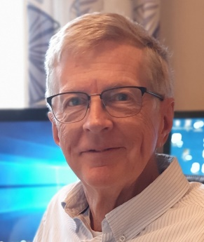 | Björn Frenckner, MD  Professor, Fellow of ELSO  Pediatric and cardiothoracic surgeon  Besides from general pediatric surgery been working with ECMO since start of the Karolinska ECMO Centre in 1987. Used to all ECMO related surgical procedures. | bjorn.frenckner@regionstockholm.se
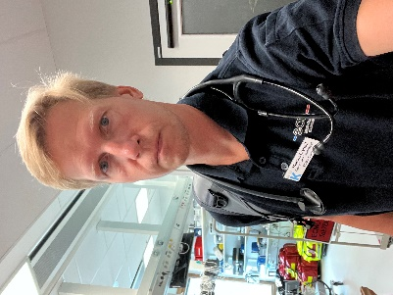 | Marcus Brynolf, MD  Consultant intensivist  Part of the ECMO unit since -21. Before my ECMO-life spent most of clinical time surrounding anesthesia and intensive care for transplantation surgery, mainly liver. | marcus.brynolf@regionstockholm.se
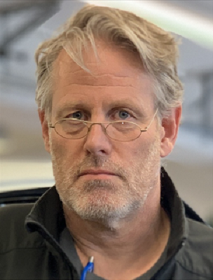 | Lars Mikael Broman, MD, PhD  Assoc. Professor, Fellow of ELSO  Sr. Consultant Intensivist  ECMO Centre Karolinska since 2011. Head of R&D. Anesthetist/intensivist from the adult side with research background in physiology. | lars.broman@regionstockholm.se
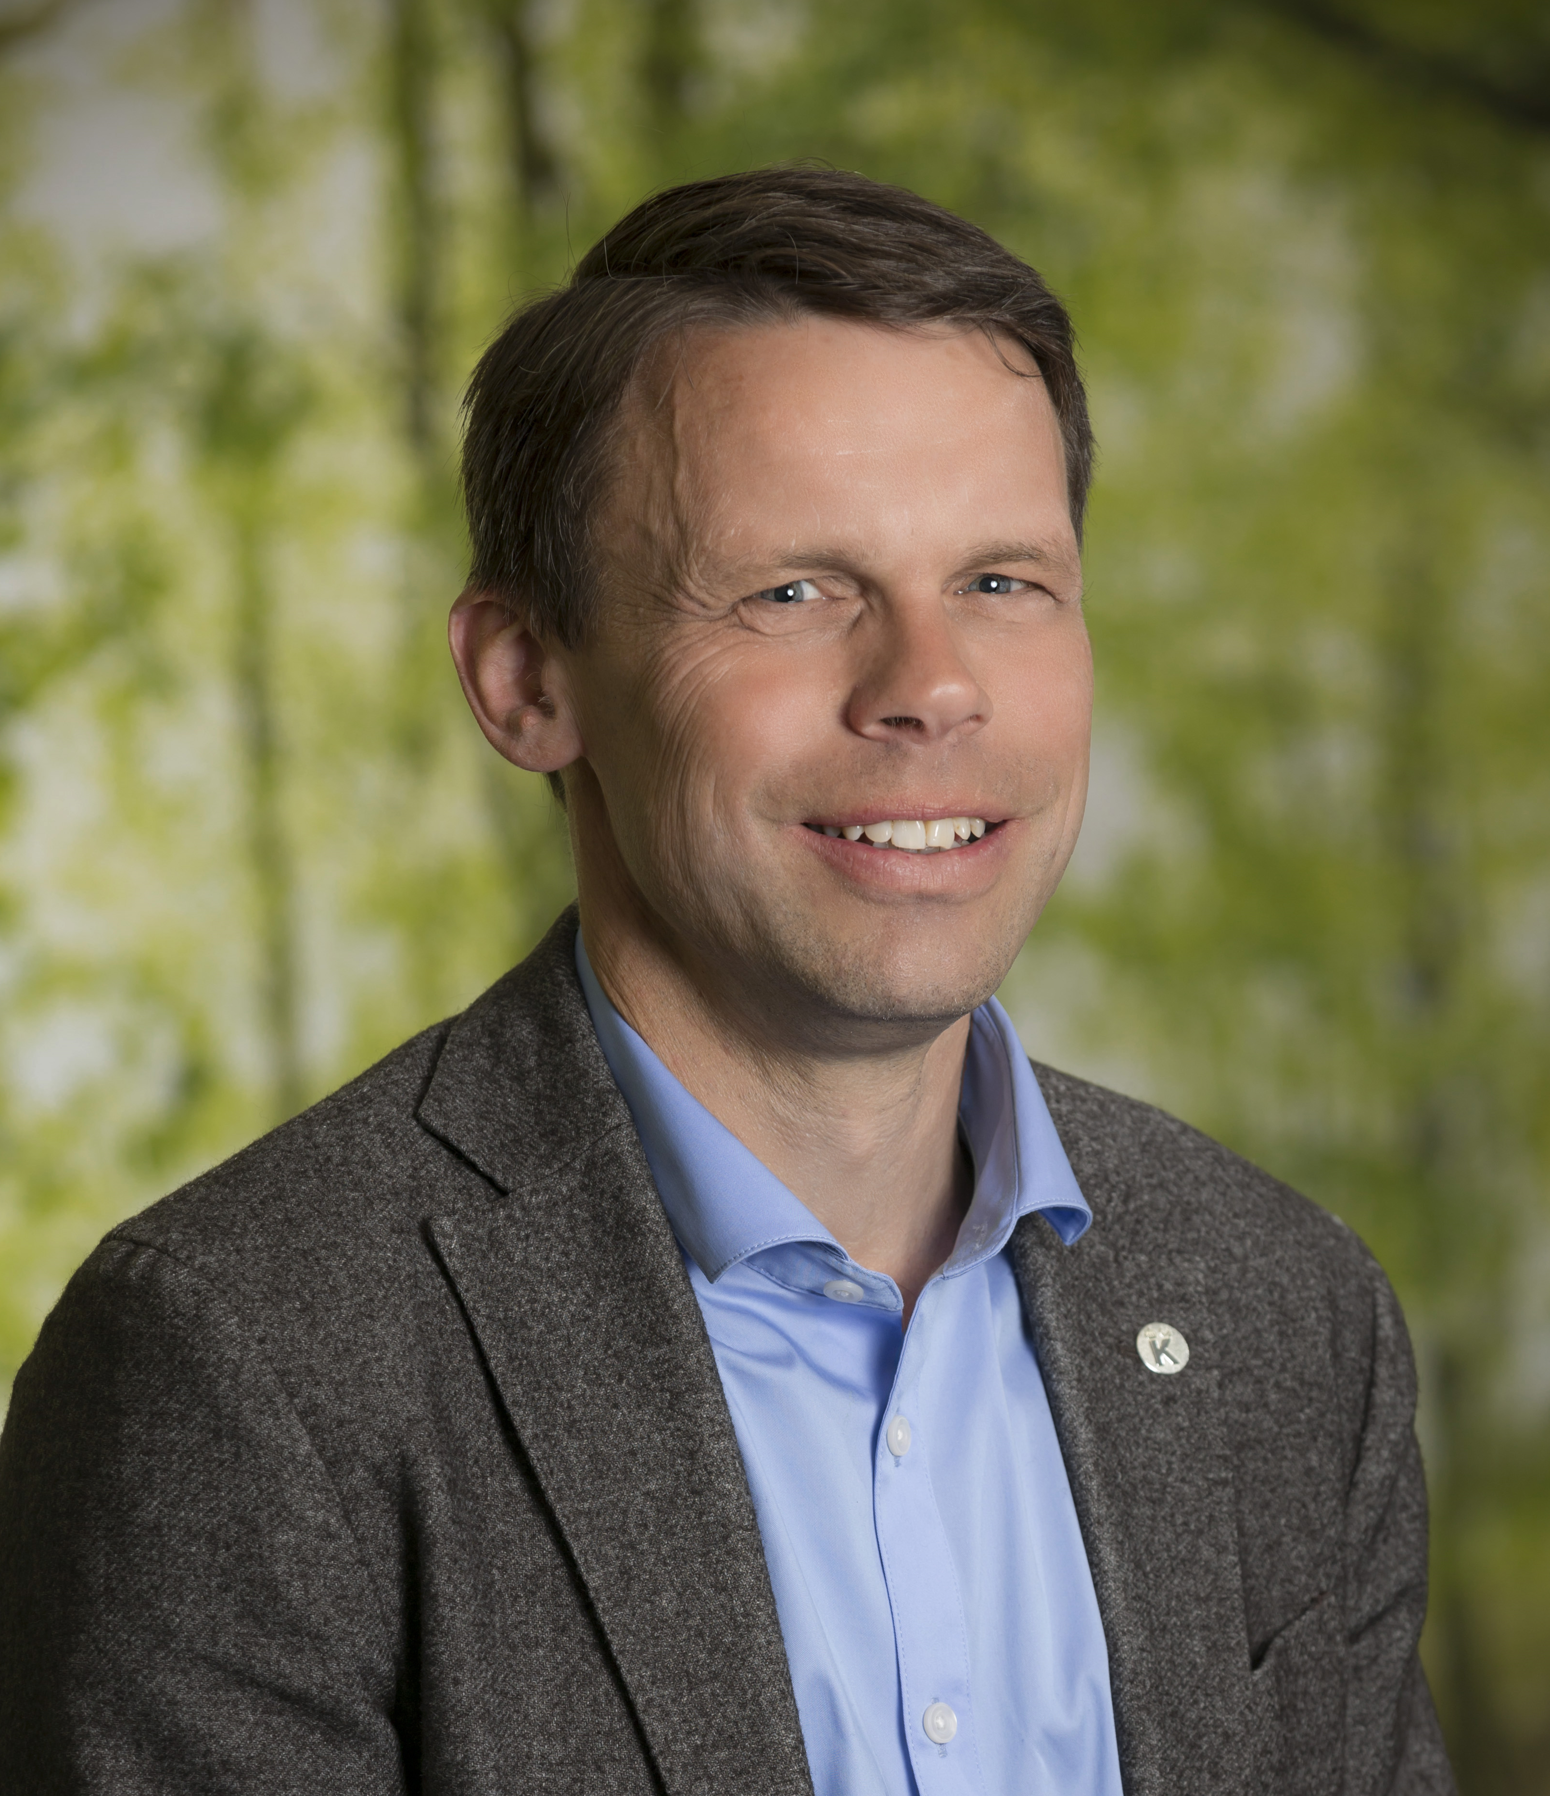 | Jonas Berner, MD PhD  Head of ECMO unit, Medical director  Sr. Consultant Intensivist  Pediatrician, anesthetist/ intensivist and researcher. First ECMO experience 2012, since 2020 mostly full time. | jonas.berner@regionstockholm.se
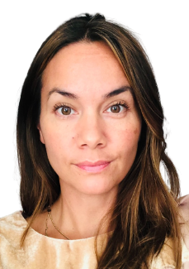 | Gemma Björndahl RN, Nurse Manager  19 years of experience in intensive care. Ecmo nurse specialist. Part of the ecmo unit since 2012. | guillerma.bjorndahl@regionstockholm.se
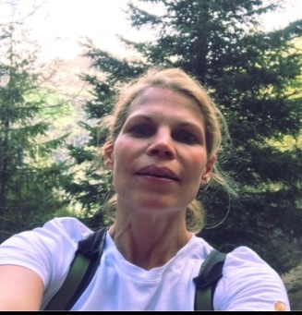 | Karin Frisell, MD  Consultant intensivist  ECMO Centre Karolinska since 2021. Background as head of a mixed ICU and a few years at PICU Karolinska. | Karin.frisell@regionstockholm.se
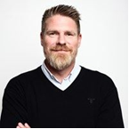 | Henrik Bucht, RN, Nurse Manager  15 years of experience as a manager in pre-hospital care, primary care, medical cars, emergency response center  Part of ECMO Centre since 2021,  Specialized in pre-hospital care | Henrik.bucht@regionstockholm.se
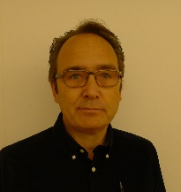 | Anders Eriksson, MD  Consultant intensivist  Background in military and civilian critical care transport. Part of the ECMO-unit since 2012. Responsible for our ECMO-transport program | anders.b.eriksson@regionstockholm.se
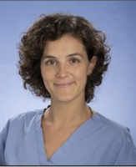 | Julia Tejero Aranguren, MD, PhD  Consultant intensivist  Adult intensivist part of the ECMO-Centre since 2023. Special interest for echocardiography in critical ill patients. Responsible for post-ECMO follow-up program. | julia.tejero-aranguren@regionstockholm.se
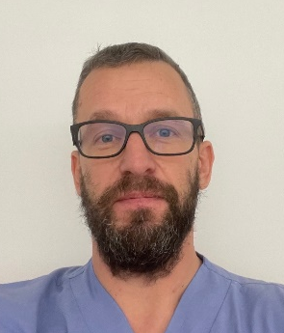 | Jakob Forestier, MD  Consultant intensivist  Anesthetist working at the ECMO Centre since 2016. Shared responsibility for continuous wetlab practices and simulations for the staff. | jakob.forestier@regionstockholm.se
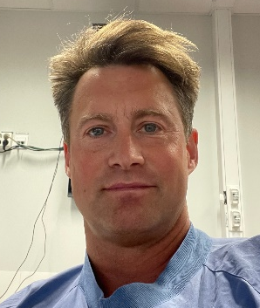 | Pär Forsman, MD  Consultant intensivist  ECMO Centre Karolinska since 2011. Responsibility for ECPR, M&M and pharmaceutical treatments. Research in ECMO and trauma.  Consultant Ambulance Helicopter and Rapid Response Cars Stockholm. | par.forsman@regionstockholm.se
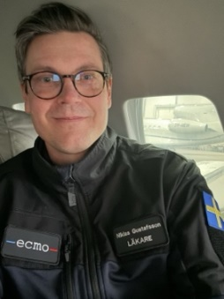 | Niklas Gustafsson, MD  Consultant intensivist  Anesthetist working at the ECMO Centre since 2019. Shared responsibility for continuous wetlab practices and simulations for the staff. | Niklas.gustafsson@regionstockholm.se
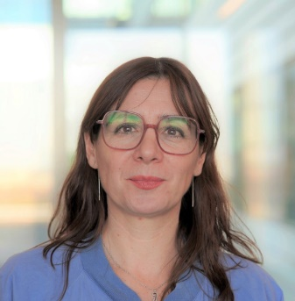 | Carmen Mesas Burgos, MD, PhD  Associate Professor KI  Senior Consultant Pediatric Surgeon  Clinical expertise on congenital anomalies, particularly congenital diaphragmatic hernia. Part of ECMO team since 2018. | carmen.mesas-burgos@regionstockholm.se
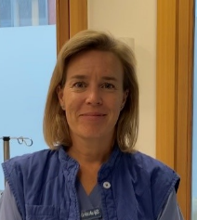 | Anna Lindberg, RN  ECMO coordinator/Clinical nurse educator  ICU nurse working at ECMO Centre since 2007. Part of the transport team and educational team. | anna.g.lindberg@regionstockholm.se
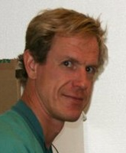 | Jonas Andersson Lindholm, MD  Consultant intensivist  Active in the ECMO program since 2009. Current research interest: ECMO physiology, infection therapy in the ICU, CRRT and plasmapheresis. Introduced NRP program in Sweden. | jonas.andersson-lindholm@regionstockholm.se
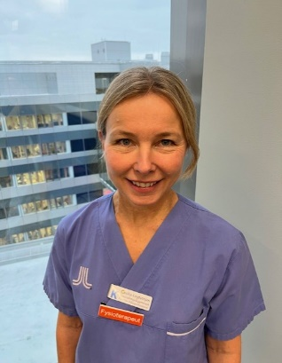 | Cecilia Lindström, Physiotherapist  MSc clinical specialist physiotherapist  At ECMO Centre and Pediatric ICU since 2010. Before ECMO, 10 years’ experience from adult ICU | cecilia.lindstrom@regionstockholm.se
 | Peter Elfström, MD, PhD  Senior Consultant, Pediatric Cardiology | peter.elfstrom@regionstockholm.se
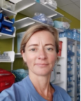 | Mia Persson, RN  ECMO specialist nurse and medical, technical coordinator  ECMO Centre Karolinska since 2007 Shared responsibility for continuous wetlab practices and simulations for the staff. | mia.persson@regionstockholm.se
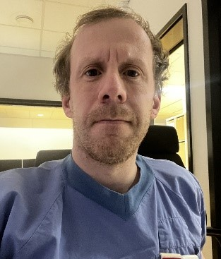 | Jan Svoboda, MD  Consultant Radiologist / Pediatric radiologist  Working at Astrid Lindgren Children’s Hospital and serving ECMO since 2016 | jan.svoboda@regionstockholm.se
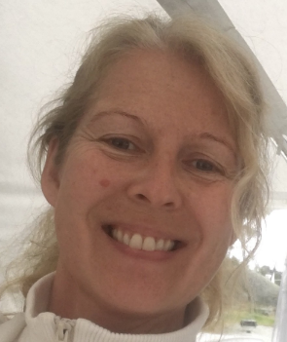 | Ann Tjärn, RN  ECMO Specialist Nurse since 2006. Active in the transport team from 2011 and senior nurse. Have had several ECMO presentations both within Sweden and abroad. | ann.tjarn@regionstockholm.se
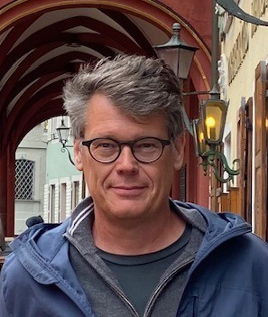  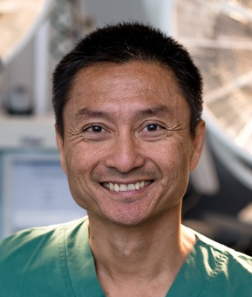 | Jerker Westlund, RN  RN 1991, ICU nurse 2001  Worked with urology 10 years  Adult ICU 10 years  ECMO center (ECMO specialist) since 2011, part of the educational and transport team (2015)  Phan-Kiet Tran, MD, PhD  Assoc. Prof., Chief of Pediatric Cardiac Surgery, Children’s Heart Center in Lund  Introduced to ECMO by Prof. Björn Frenckner in 2005. From clinical practice, use of ECMO pre- and postoperatively in neonates up to 18 years old patients with failing hemodynamics. | jerker.westlund@regionstockholm.se  phan.kiet.tran@skane.se

