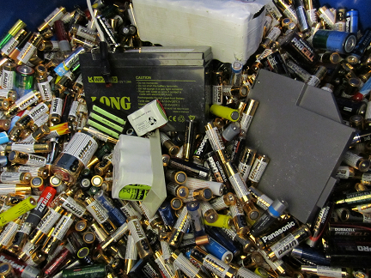



Always check that the printed copy is up to date. A new version may have been created since the printout.

**Handling**

Papers, as well as adhesive labels, are to be deposited directly into the bin for confidential waste.

Occasional confidential waste consisting of other materials can be deposited directly into the bin as well. If you have a greater amount of confidential waste consisting of other materials, please order a separate bin.

The bin can be ordered already locked or with a separate security lock allowing departments to lock the bin themselves when it is full.

Always specify whether you want to have the bin sealed/locked when delivered!

***Pick-up***

Order pick-up by the icon *transportbeställning* on the first page on Inuti.

**Confidential waste**

Kopia på digitalt original

**Yes please:** Paper and other confidential material (labels with adhesive reverse, overhead films, carbon copies, plastic pockets, ink ribbon from printers incl. cartridge, patient trays, CDs, disks, video tape, X-ray films, photographic paper, thermopaper, echo images etc).

**No thank you**: Paper and other material which does not contain any confidential information



|  |  |  |  |
| --- | --- | --- | --- |
| Löpnummer | Gäller fr o m | Handläggare | Fastställare |
| STAB0069 | 2020-05-05 | Ewa Frank/Karolinska/SLL | Gustav L Eriksson/Karolinska/SLL |